1C. To set up a truth table for the design using 24hrs clock timing we need five variable inputs
TRUTH TABLE
decimal | A | B | C |  | F(output)
0 | 0 | 0 | 0 | 0 | 0
1 | 0 | 0 | 0 | 1 | 0
2 | 0 | 0 | 1 | 0 | 0
3 | 0 | 0 | 1 | 1 | 0
4 | 0 | 1 | 0 | 0 | 1
5 | 0 | 1 | 0 | 1 | 1
6 | 0 | 1 | 1 | 0 | 1
7 | 0 | 1 | 1 | 1 | 1
8 | 1 | 0 | 0 | 0 | 1
9 | 1 | 0 | 0 | 1 | 1
10 | 1 | 0 | 1 | 0 | 1
11 | 1 | 0 | 1 | 1 | 1
12 | 1 | 1 | 0 | 0 | 0
13 | 1 | 1 | 0 | 1 | 1
14 | 1 | 1 | 1 | 0 | 1
15 | 1 | 1 | 1 | 1 | 0
5MARKS

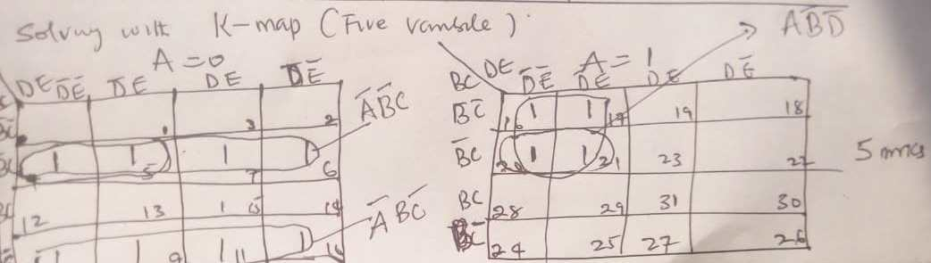

- Simplify the Boolean function in (i) using Karnaugh (Maps (K-map);
- F(A,B,C,D) = Σ_{m} (1,3,5,7,9,11,13,15) (5 marks)
(c ) Design a basic logic gates and write its corresponding Boolean function to activate a b a crane loader. The car park will be used during the months of February to June, and September to December. Use yearly calendar for your design. (7marks)

Answer
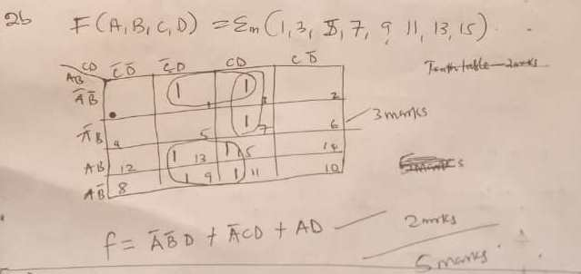
2C, Set up the truth table first
Month | A | B | C | D | E
JAN | 0 | 0 | 0 | 0 | 0
FEB | 0 | 0 | 0 | 0 | 1
MAR | 0 | 0 | 0 | 1 | 0
APR | 0 | 0 | 0 | 1 | 1
MAY | 0 | 0 | 1 | 0 | 0
JUN | 0 | 0 | 1 | 0 | 1
JUL | 0 | 0 | 1 | 1 | 0
AUG | 0 | 0 | 1 | 1 | 1
SEP | 0 | 1 | 0 | 0 | 0
OCT | 0 | 1 | 0 | 0 | 1
NOV | 0 | 1 | 0 | 1 | 0
DEC | 0 | 1 | 0 | 1 | 1
2marks
The K-map and logic diagram.
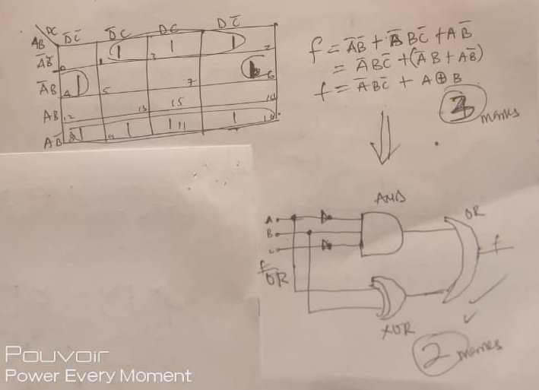
5mark
QUESTION TWO
2a Sequential circuits, the output variables depend not only on the present input variable but upon the past history of these variable. Memory unit is required to store the past history of input variable in sequential circuits. The sequential circuit are slower than the combinational circuits. Serial adder is a sequential circuit.
2b
s/n | Synchronous sequential circuits | Asynchronous sequential circuits
1 | The memory elements are clocked flip-flops | The memory elements are either unclocked flip-flops or time delay elements
2 | The change in input signal can affect memory element upon activation of clock signal | The change in input signal can affect memory element at any instant of time
3 | The maximum operating speed of clock depends on time delays involved | Because of absence of clock, asynchronous circuit can operate faster than synchronous circuit
4 | Easier to design | More difficult to design

Differentiate between Flip-Flops and Latches in a sequential device
Flip-Flops- is a sequential device that normally samples its inputs and changes its output only at times determined by clocking signal.
Latch- is a sequential device that normally checks all of its inputs continuously and changes its outputs accordingly at any time independent of a clocking signal. Many times enable signal is provided with the latch. When enable signal is active changes occur as input changes but when enable signal is not activated input changed do not affect output.

Draw and explain the working of RS Latch using NOR gates
RS Latch using NOR gates
Set/reset (SR) latch
1
0
R
Q⁻
Q
1
2
1

S
0

In this case, s input of the NoR gate2 is at logic1, hence its output Q⁻ is at logic 0. Both inputs to NOR gate 1 are now at logic 0. So that its output,Q is at logic1. The same diagram should be repeated for the truth table
S | R | Qn | Qn+1 | State
0 | 0 | 0 | 0 | No change(NC)
0 | 0 | 1 | 1 | No change(NC)
0 | 1 | 0 | 0 | Reset
0 | 1 | 1 | 0 | Reset
1 | 0 | 0 | 1 | set
1 | 0 | 1 | 1 | set
1 | 1 | 0 | X | Indeterminate
1 | 1 | 1 | X | Indeterminate

Explain types of Shift Registers with diagrams [5marks]
Shift Registers: whenever the binary information(data) in a register can be moved from stage to stage within the register or into or out of the register upon application of clock pulses. This movement or shifting is important for certain arithmetic and logic operations used in microprocessors. The registers that handle such movement are call shift register. There are six types of shift registers
- Serial shift right, then out
- Serial shift left, then out
- Parallel shift in
- Parallel shift out
- Rotate right
- Rotate left
Describe five application of shift register [10marks]
- Delay line
- Serial to parallel Converter
- Parallel to serial Converter
- Shift Register counter
- Pseudo-Random Binary Sequence(PRBS) generator
- Sequence Generator
- Sequence Detector
- Serial adder/subtractor

